
https://www.21twelveinteractive.com/xampp-vs-wamp/:

XAMPP vs WAMP: Which is the Best Local Server for WEB Development?
Posted: November 22, 2019 By: Nikita
Contents
ABOUT XAMPP 2
Pros of XAMPP 3
Cons of XAMPP 3
ABOUT WAMP 3
Pros of WAMP 3
Cons of WAMP 3
Similarities between XAMPP vs WAMP 3
Differences between XAMPP vs WAMP 4
Use Interface 4
Installation 4
Performance 4
Security 4
That’s a Wrap on XAMPP vs WAMP Debate! 5
Popular FAQ: 5
Which is Better, XAMPP or WAMP for WEB Development? 5
What is XAMPP and Its Features? 5
What is WAMP and Its Features? 5

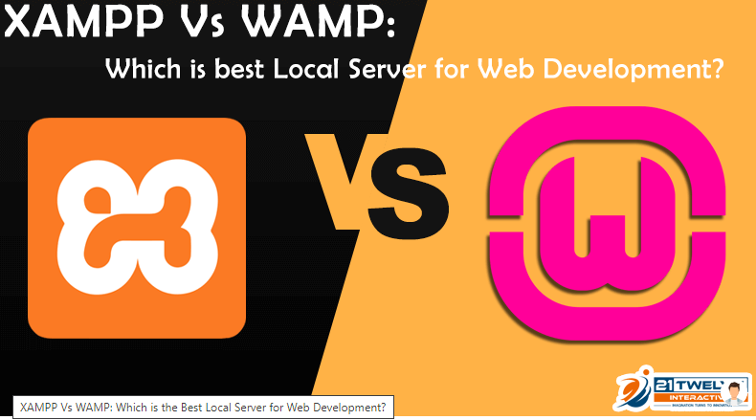
XAMPP vs WAMP is a debate that is doing the rounds since forever. Just like any other comparison out there, both these servers have their own set of pros and cons.
Of course, a WordPress development company will be able to tell you better. Here we will be doing a comparative study between WAMP vs XAMPP local server.
Before we get down to the eternal XAMPP vs WAMP debate, let’s discuss the most basic things!
Yes, you have heard about local servers, but do you know why developers use them? Do you know the benefits of using a local server for your project?
When a server is locally hosted on your laptop or computer, it is called a local server. These local servers help developers to test a website multiple times before making it live on the internet.
XAMPP and WAMP are local servers. By testing your software locally on these servers, you can find bugs and errors before going live. Such advanced testing can save you and your brand from a lot of trouble once your website is live!
The blog outline is as follows:
- About XAMPP
- About WampServer
- Similarities between XAMPP & WampServer
- Differences between XAMPP & WampServer
- Conclusion

ABOUT XAMPP
The full form of XAMPP is Cross-platform, Apache, MariaDB, PHP, and Perl. One of the main XAMPP features is that it is the simplest and most light-weight local servers to use.
XAMPP is an open-source platform and works on all the major operating systems like Windows, Mac, Linux, etc. As it is an open-source platform, you can download and install it in your system easily.
Its other features include Filezilla, mercury mail and Perl support, etc. If you need an advanced set of features in your local server, then XAMPP is the ideal choice.
Furthermore, experienced developers can work on multiple languages with XAMPP. Listed below are some of the XAMPP pros and cons.

Pros of XAMPP
- In XAMPP vs WAMP, XAMPP is easier to install
- XAMPP is multi cross-platform i.e. it is available for Windows and Linux
- It comes with many other modules like OpenSSL, MediaWiki, Joomla, WordPress and much more.
- It is available in a full as well as a standard version.
- A single command can begin and end the whole web server + database stack.

Cons of XAMPP
- Configuration and settings are difficult as compared to WAMP.

ABOUT WAMP
The full form of the WAMP server is Windows, Apache, MySQL, and PHP. Just like XAMPP, it is an open-source platform too. Apart from that, WAMP uses the Apache web server, MySQL relational database management system and PHP language.
WAMP enables you to test dynamic websites on the local server without making it live. Not only is it easy to use but also available for both 32 and 64-bit systems.
If you are going to deal only with native web applications, then WAMP is the ideal choice. Listed below are some of the WAMP pros and cons.

Pros of WAMP
- Changing the configurations is easy in WAMP.
- It makes PHP coding and creation of databases in the Windows platform easy.
- It is available for both 64-bit and 32-bit systems.

Cons of WAMP
- It is not as easy to install as XAMPP.
Hopefully, you are clear with the concepts of XAMPP and WAMP by now. So, let’s come down to the agenda of this blog – XAMPP is better or WAMP!

Similarities between XAMPP vs WAMP
XAMPP and WAMP both are free and open-source web server packages to run a web server on your PC. They both contain Apache server and PHP apart from other software that is an absolute must to run a website/web application.
The basic advantage with both is that you don’t have to individually download Apache, PHP, and MySQL, etc. to make a web server work on your computer. All you must do is download their installers from respective websites and then install XAMPP and WAMP on your computer.
You can use either of these web server packages to test your PHP based CMSs, blogs, and applications on your PC by downloading Joomla, Drupal or WordPress.

Differences between XAMPP vs WAMP

Use Interface
As both contain multiple software, they come with user-friendly control panels. A control panel can be called a graphical user interface used to switch off/on each component software in XAMPP and WAMP.
XAMPP and WAMP both have a control panel with start/stop buttons for individual components while they are running.
Thus, when it comes to the user interface in XAMPP vs WAMP, both are similar, and a winner can’t be declared.

Installation
XAMPP and WampServer both can be very easily installed. You just must download the installer and you can install it. WampServer for Linux, Windows 7, 8, 10 and Mac OS X is available. Similarly, if you own a Windows laptop or PC, you can install XAMPP just like any other application.
Although installing XAMPP and Wamp on the same computer is possible, you can’t run them at the same time. Again, XAMPP vs Wamp is similar in terms of ease of installation too.

Performance
The basic software components are similar in both. However, XAMPP comes with additional software tools like Mercury Mail, FileZilla FTP server and Tomcat. Therefore, XAMPP’s size of the installer is bigger than that of WampServer.
If you have the Mac OS X or Linux operating system on your computer, then XAMPP is an ideal choice. The reason being WampServer is only for the Windows operating system. If you have a Windows PC, then you can choose between XAMPP and Wamp as per your requirements.
In Wamp vs XAMPP performance, it can be said that the XAMPP server has an upper hand.

Security
Anyone would require a secure web server package given the current situation in the market. The internet is full of vulnerabilities that can be a threat to your website.
Apart from the difference in the operating system, another major difference between XAMPP and WAMP is security. If you are working on a project that does not have sensitive information at stake, then choose XAMPP. XAMPP can be used to host local websites but a lot of security measures will be needed.
But if you are working on a project where security is a priority, then choose WAMP because it has been created keeping security in mind. Of course, the condition with WAMP is that you should be using the Windows operating system.
Hence, when it comes to the XAMPP vs Wamp security debate, Wamp is the clear winner!

That’s a Wrap on XAMPP vs WAMP Debate!
After the detailed discussion on XAMPP vs WAMP debate, it can be safely said that they are almost similar. Both are efficient local servers that you can completely trust for the successful implementation of your dream project.
The major differences between them are the operating systems in which they can run and security concerns. However, both can be an ideal choice for different types of projects.
Some instances of an alternative to WAMP server are XAMPP, Laragon, MAMP, AMPPS, UwAmp, EasyPHP, BitNami Application Stacks, The Uniform Server, and Open Server, etc.
Some instances of an alternative to the XAMPP server are AMPPS, EasyPHP, WampServer, MAMP, WPN-XM, Wnmp, and DesktopServer, etc.
When you hire a web developer, you will get a better idea of what is the appropriate choice for your project!
Are you looking to hire expert web developers for your upcoming project? Drop a mail to us on info@21twelveinteractive.com and we will make sure your project requirements are fulfilled!

Popular FAQ:

Which is Better, XAMPP or WAMP for WEB Development?
XAMPP is more powerful as compared to Wamp. Also, XAMPP has the SSL feature which Wamp lacks. Wamp is the perfect choice for native web applications and XAMPP is when you need an advanced set of features in your web server package.

What is XAMPP and Its Features?
XAMPP, developed by Apache Friends, is an open-source cross-platform web server package. It comprises of the Apache HTTP server, MariaDB database, and interpreters for PHP and Perl scripts.

What is WAMP and Its Features?
WAMP is an acronym. The full form is Microsoft Windows, Apache, MySQL and PHP, Perl or Python. Wamp is useful to the developers as they can easily switch between the security and developers’ functionality.

